Week 1 Internship Report
Data Acquisition, Cleaning, and Preprocessing — HR Analytics Dataset
Prepared using the HR Analytics.xlsx dataset supplied for the internship task

Item | Details
Dataset | HR Analytics.xlsx
Primary sheet | HR Analytics
Original rows | 1,471
Usable employee records after removing spreadsheet total row | 1,470
Original columns | 32
Final analysis columns | 31
Tool | Python (pandas, NumPy, matplotlib)
Deliverable | Data-quality report + reproducible preprocessing code

1. Executive Summary
The supplied HR Analytics workbook contains 1,470 employee records after removing one spreadsheet-level Total row. The dataset contains demographic, compensation, job, satisfaction, travel, overtime and attrition variables.
Quality checks identified 2 missing cells in the employee-level data and 0 duplicate rows. The main structural issues were one missing DistanceFromHome value, one missing EmployeeNumber, a spreadsheet Total row, and an otherwise empty free-text artifact column.
For preprocessing, the missing distance was imputed with the median (7 km). The missing employee identifier was coded as -1 rather than inventing a real identifier. IQR-based screening was performed on numeric variables; detected statistical outliers were retained when they were plausible business values rather than automatically deleted.
The overall observed attrition rate in the cleaned analysis dataset is 16.12%. Exploratory results show that overtime status and age group are especially useful descriptive dimensions for understanding attrition.

2. Data Acquisition and Dataset Understanding
The input workbook was supplied with the internship task. The workbook contains two sheets: an HR Analytics data sheet and an Operations Sheet containing suggested analytical questions. The first sheet was used as the main dataset.
The structure is consistent with a commonly used HR employee-attrition dataset. IBM documentation for its Watson Studio example references the HR employee attrition file and uses Attrition as the target field. The report therefore treats the supplied workbook as the working copy for this internship rather than silently replacing it with another dataset.
- Record unit: one employee record per row.
- Target/status variable: Attrition (Yes/No).
- Numeric examples: Age, DailyRate, HourlyRate, MonthlyIncome, MonthlyRate, PercentSalaryHike.
- Categorical examples: Department, JobRole, Gender, BusinessTravel, OverTime, MaritalStatus.
- Ordinal satisfaction variables: EnvironmentSatisfaction, JobSatisfaction, JobInvolvement and RelationshipSatisfaction.
Initial loading code:
df = pd.read_excel("HR Analytics.xlsx", sheet_name="HR Analytics ")
print(df.shape)
print(df.head())
print(df.info())

3. Initial Data Exploration
The raw sheet loaded as 1,471 rows × 32 columns. One final row was labeled Total and contained no employee-level observations; it was removed before analysis. One extra column contained a single free-text response followed by 1,470 blank cells and was treated as a spreadsheet artifact.
Check | Result | Interpretation
Raw shape | 1471 × 32 | Includes spreadsheet artifacts
Employee rows after Total-row removal | 1,470 | Used for analysis
Duplicate complete rows | 0 | No exact duplicate records found
Missing employee-level cells | 2 | Two missing values after structural cleanup
Text/categorical columns | 12 | Requires category consistency checks
Numeric columns | 19 | Suitable for summary and outlier screening
Example exploratory checks:
print("Duplicates:", df.duplicated().sum())
print(df.isna().sum())
print(df.describe(include="all").T)

4. Missing Values and Data Quality Issues
Column | Missing values before imputation
DistanceFromHome (km) | 1
EmployeeNumber | 1
The missing-value pattern is very small and localized. The missing DistanceFromHome value can reasonably be estimated from the distribution of that variable. The missing EmployeeNumber is different: it is an identifier, not an analytical measurement. Replacing it with a median employee number would create a false identifier, so it is explicitly represented as -1 in the analysis-ready dataset.
distance_median = df["DistanceFromHome (km)"].median()
df["DistanceFromHome (km)"] = df["DistanceFromHome (km)"].fillna(distance_median)
df["EmployeeNumber"] = df["EmployeeNumber"].fillna(-1)

This approach preserves the distinction between an estimated measurement and an unknown identifier.

5. Data Cleaning and Preprocessing
- Removed the spreadsheet Total row because it is not an employee record.
- Removed the mostly empty Unnamed: 31 column because it does not provide usable analytical information.
- Renamed Unnamed: 0 to EmployeeID for clarity.
- Stripped leading/trailing whitespace from text fields.
- Converted DistanceFromHome (km) to numeric so that it can be summarized and checked correctly.
- Checked duplicate rows; no exact duplicates were found.
- Kept plausible high values rather than deleting observations only because an IQR rule flagged them.
- Created a cleaned CSV and an analysis-ready CSV for reproducibility.
df.columns = [str(c).strip() for c in df.columns]
df = df.loc[~df["Unnamed: 0"].astype(str).str.strip().str.lower().eq("total")]
df = df.drop(columns=["Unnamed: 31"], errors="ignore")
df = df.rename(columns={"Unnamed: 0": "EmployeeID"})
for col in df.select_dtypes(include="object").columns:
df[col] = df[col].astype("string").str.strip()
df["DistanceFromHome (km)"] = pd.to_numeric(df["DistanceFromHome (km)"], errors="coerce")

6. Outlier Detection and Treatment
The Interquartile Range (IQR) rule was used as a screening technique: values below Q1 − 1.5×IQR or above Q3 + 1.5×IQR were flagged. An outlier flag is not automatically a data error. HR data can naturally contain high salaries, long travel distances, or employees with several previous employers.
Variable | Flagged | IQR lower | IQR upper | Observed max
DistanceFromHome (km) | 1 | -16.00 | 32.00 | 100.00
MonthlyIncome | 114 | -5291.00 | 16581.00 | 19999.00
NumCompaniesWorked | 52 | -3.50 | 8.50 | 9.00
PerformanceRating | 226 | 3.00 | 3.00 | 4.00
The strongest obvious candidate for manual review is DistanceFromHome = 100 km, because it is far above the typical range. However, it is not intrinsically impossible and no evidence in the workbook proves that it is an input error, so it was retained. MonthlyIncome values up to 19,999 and NumCompaniesWorked up to 9 are also plausible. PerformanceRating is bounded and ordinal, so the IQR rule is not an appropriate reason to remove rating 4 records.
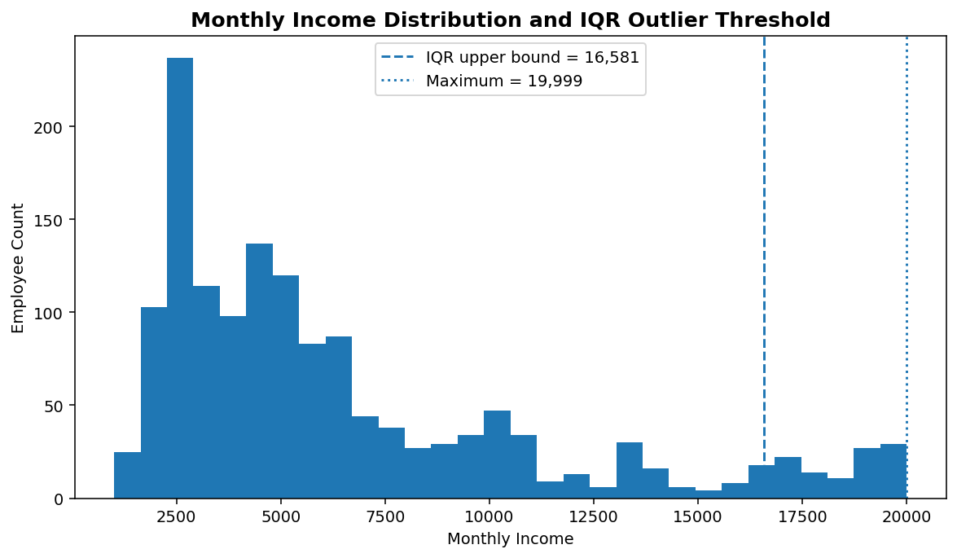
Figure 1. Monthly income distribution and the IQR screening threshold.
for col in df.select_dtypes(include=np.number).columns:
q1, q3 = df[col].dropna().quantile([0.25, 0.75])
iqr = q3 - q1
lower, upper = q1 - 1.5*iqr, q3 + 1.5*iqr
flags = ((df[col] < lower) | (df[col] > upper)).sum()
print(col, flags)

7. Exploratory Analysis
The Operations Sheet suggested questions such as gender versus hourly rate, average salary by job title, department versus attrition, satisfaction relationships, and attrition by age generation. The following visuals answer those questions using the cleaned data.
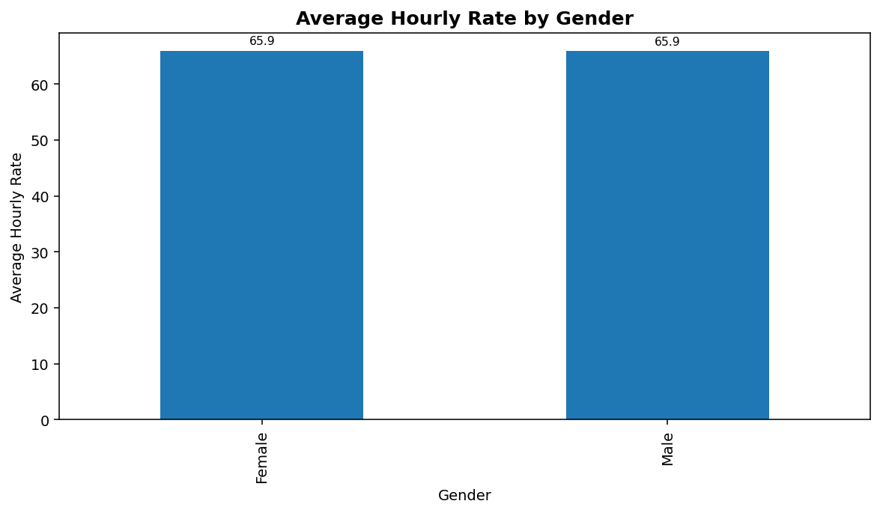
Figure 2. Average hourly rate by gender. The difference is negligible in this dataset.
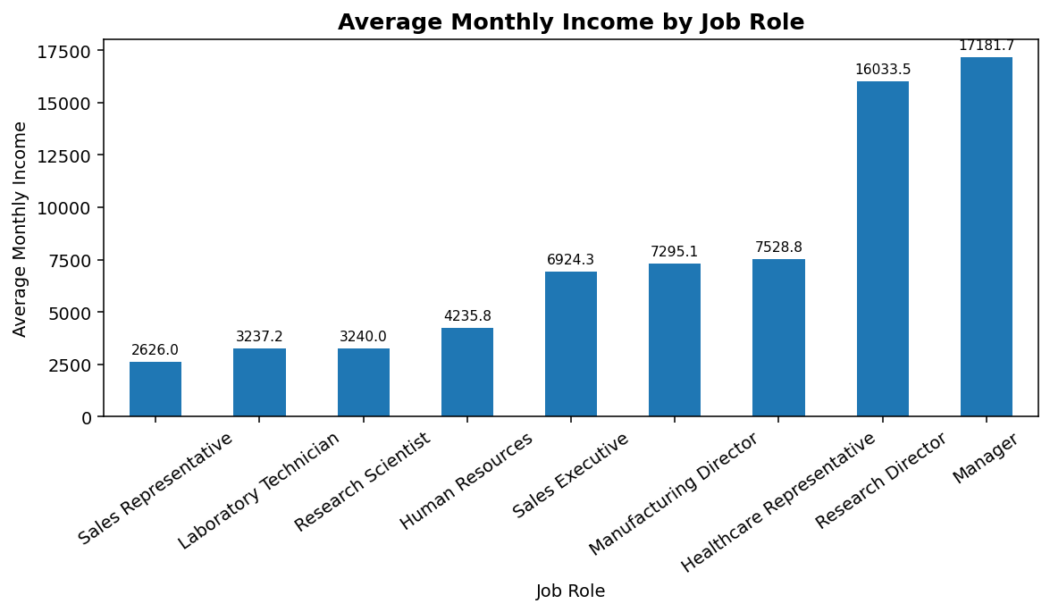
Figure 3. Average monthly income by job role. Manager and Research Director are highest on average.
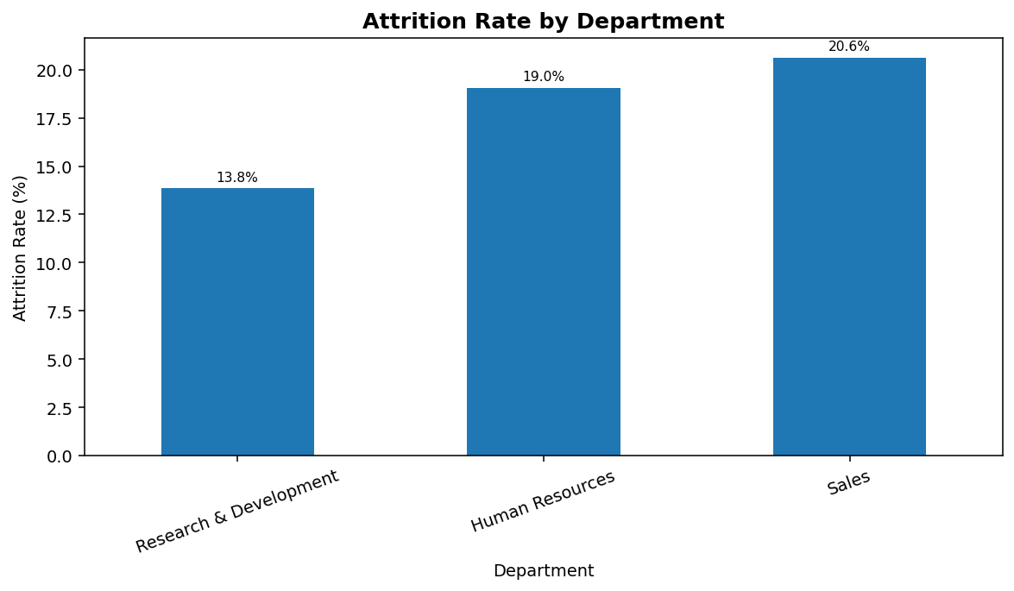
Figure 4. Attrition rate by department. Sales has the highest observed department-level rate.
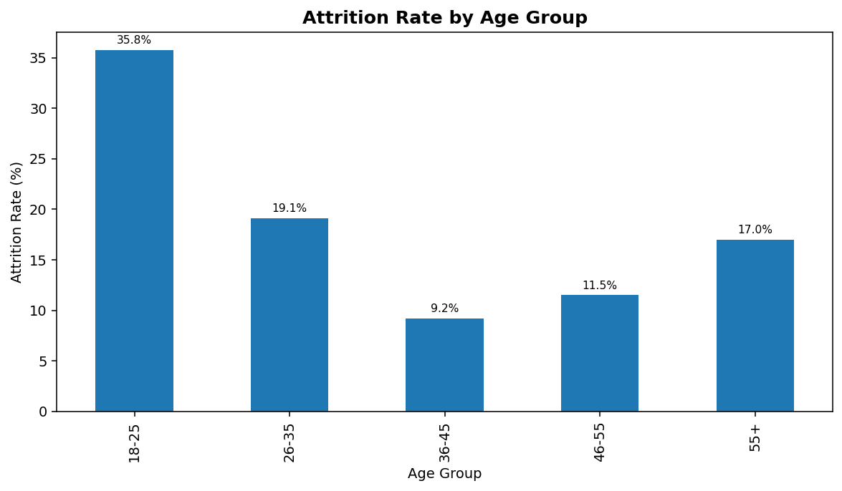
Figure 5. Attrition rate by age group. The 18–25 group has the highest observed rate.
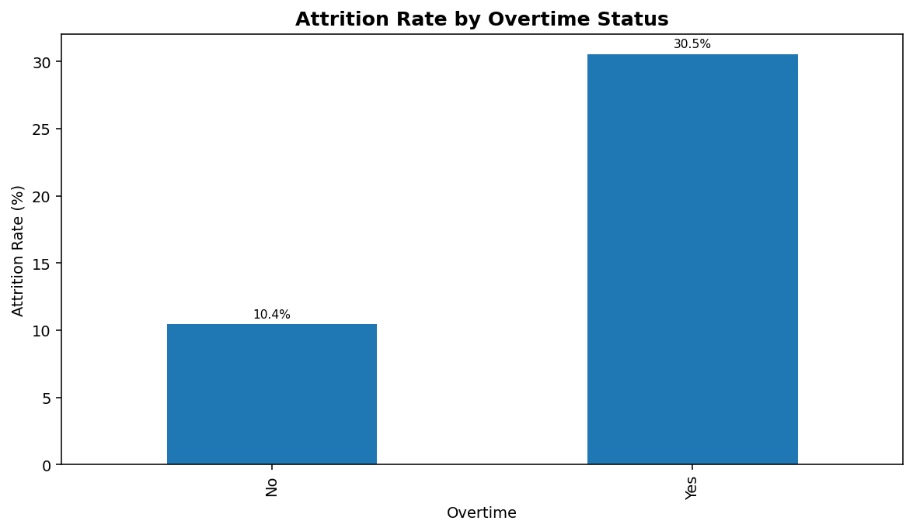
Figure 6. Attrition rate by overtime status. Overtime is strongly associated with higher observed attrition.
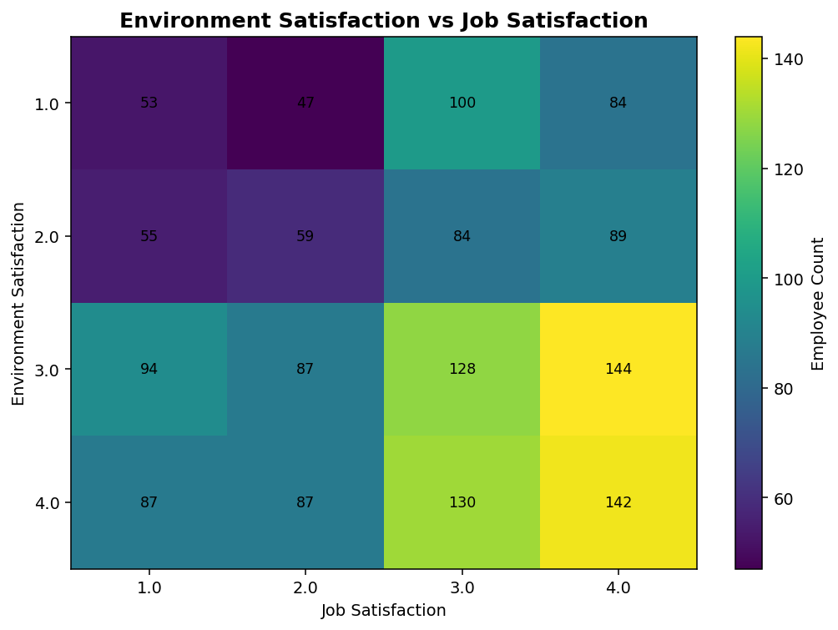
Figure 7. Employee counts across Environment Satisfaction and Job Satisfaction levels.

8. Key Findings
- Overall attrition: 16.12% of employees are marked as having left.
- Average hourly rate is almost identical for Female (65.90) and Male (65.88).
- Average monthly income is highest for Manager (17,181.68) and lowest for Sales Representative (2,626.00).
- Sales has the highest observed department attrition rate at 20.63%.
- The 18-25 age group has the highest observed attrition rate at 35.77%.
- Employees working overtime show 30.53% attrition versus 10.44% without overtime.
- These are descriptive associations, not causal conclusions. Additional analysis would be needed before making HR policy decisions.

9. Potential Impact of Preprocessing on Future Analysis
- Removing the Total row prevents summary values from being accidentally treated as an employee record.
- Removing the empty artifact column reduces noise and prevents irrelevant text from entering feature-selection workflows.
- Converting distance to numeric enables correct descriptive statistics, visualizations and machine-learning preprocessing.
- Median imputation for the single missing distance value prevents unnecessary row deletion while minimizing sensitivity to extreme values.
- Explicitly coding the missing employee identifier avoids fabricating a real employee number.
- Retaining plausible outliers preserves potentially meaningful HR cases; future modeling can compare results with and without robust outlier handling.
- The cleaned dataset is now in a form suitable for further EDA, classification modeling, feature engineering and dashboarding.

10. Challenges and How They Were Overcome
Challenge | Action taken | Reason
Spreadsheet Total row | Removed one non-employee row | Prevents contamination of employee-level analysis
Mostly empty free-text column | Dropped Unnamed: 31 | No useful analytical signal
Missing distance | Median imputation (7 km) | Only one value missing; keeps the record
Missing employee number | Use -1 as unknown | Avoids inventing a false identifier
Potential outliers | IQR screening + business judgment | Statistical flag ≠ data error
Mixed data types | Numeric conversion and text normalization | Improves reproducibility and downstream analysis

11. Reflective Commentary
The main lesson from this preprocessing exercise is that cleaning should be driven by the meaning of the data, not only by automated rules. For example, an IQR calculation can flag a high salary or a performance rating even when the value is valid. Similarly, an identifier should not be median-imputed just because a numerical column contains a missing value. The cleaning choices therefore distinguish structural errors, missing measurements, missing identifiers and legitimate extreme observations.
For a future modeling task, I would add automated validation rules for allowed categories, range checks for ordinal fields, duplicate identifier checks, and a separate data-quality log. I would also evaluate whether imputations affect model performance through a train/test-safe preprocessing pipeline.

12. Conclusion
The Week 1 task has been completed using the supplied HR Analytics dataset. The workflow acquired the workbook, profiled its structure, identified missing values and spreadsheet artifacts, cleaned and standardized fields, screened numeric variables for outliers, documented the treatment decisions, and produced an analysis-ready dataset. The resulting files and Python script make the process reproducible and provide a strong foundation for later data analysis or machine-learning work.

Appendix A — Reproducible Python Code
The complete script is also provided as a separate .py file. The core workflow is reproduced below.
# Week 1 - Data Acquisition, Cleaning and Preprocessing
# Dataset: HR Analytics.xlsx
import pandas as pd
import numpy as np
INPUT_FILE = "HR Analytics.xlsx"
# 1) Load data
df = pd.read_excel(INPUT_FILE, sheet_name="HR Analytics ")
print(df.shape)
print(df.head())
print(df.info())
# 2) Basic quality checks
print("Duplicate rows:", df.duplicated().sum())
print("Missing values:\n", df.isna().sum())
# 3) Remove spreadsheet artifacts
df.columns = [str(c).strip() for c in df.columns]
df = df.loc[~df["Unnamed: 0"].astype(str).str.strip().str.lower().eq("total")]
df = df.drop(columns=["Unnamed: 31"], errors="ignore")
df = df.rename(columns={"Unnamed: 0": "EmployeeID"})
# 4) Standardize text
for col in df.select_dtypes(include="object").columns:
df[col] = df[col].astype("string").str.strip()
# 5) Convert distance to numeric
df["DistanceFromHome (km)"] = pd.to_numeric(
df["DistanceFromHome (km)"], errors="coerce"
)
# 6) Missing-value handling
# Only one distance value is missing, so use the column median.
df["DistanceFromHome (km)"] = df["DistanceFromHome (km)"].fillna(
df["DistanceFromHome (km)"].median()
)
# EmployeeNumber is an identifier. Do not create a fake employee number.
# Use -1 to mark an unknown identifier for analysis/export.
df["EmployeeNumber"] = df["EmployeeNumber"].fillna(-1)
# 7) IQR outlier scan for numeric variables
for col in df.select_dtypes(include=np.number).columns:
s = df[col].dropna()
if len(s) == 0:
continue
q1, q3 = s.quantile([0.25, 0.75])
iqr = q3 - q1
lower, upper = q1 - 1.5 * iqr, q3 + 1.5 * iqr
count = ((s < lower) | (s > upper)).sum()
if count:
print(f"{col}: {count} IQR outliers; bounds=({lower:.2f}, {upper:.2f})")
# 8) Save cleaned data
df.to_csv("HR_Analytics_analysis_ready.csv", index=False)
# 9) Example exploratory analysis
attrition_rate = (df["Attrition"].eq("Yes").mean()) * 100
print(f"Overall attrition rate: {attrition_rate:.2f}%")
print("\nAttrition by department:")
print(
df.groupby("Department")["Attrition"]
.apply(lambda x: x.eq("Yes").mean() * 100)
.sort_values(ascending=False)
)
print("\nAverage income by job role:")
print(df.groupby("JobRole")["MonthlyIncome"].mean().sort_values(ascending=False))
print("\nAttrition by overtime:")
print(
df.groupby("OverTime")["Attrition"]
.apply(lambda x: x.eq("Yes").mean() * 100)
)

Appendix B — Output Files
- HR_Analytics_cleaned.csv — cleaned dataset with missing values preserved after structural cleaning.
- HR_Analytics_analysis_ready.csv — cleaned dataset with the documented missing-value treatment applied.
- week1_hr_analytics.py — reproducible Python script.
- charts/ — visual evidence used in this report.
External reference used for dataset context: IBM Watson Studio HR employee attrition example (developer.ibm.com).
Note: The analysis and outputs in this report are based on the supplied HR Analytics.xlsx workbook.

